

A PARISH MINISTER/VOLUNTEER

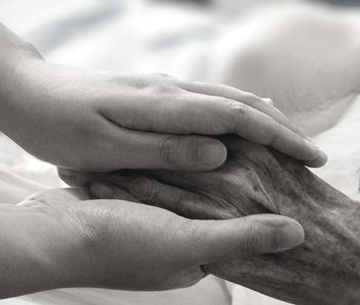

Compassionate care starts from the heart!



Finding Peace & support during serious illness



**FOR THE**

**CARING**

**I PERSON E**

**WHOLE**

**NITIATIV**

**(CWPI)**

* **Completes the CWP training**
* **Follows the CWP guidelines**
* **Supports parishioners and their families living with serious illness by preserving dignity and meaning, being fully present, listening more & talking less, and assisting with daily living activities**
* **Documents visits and reports parishioner/family needs to CWP Leader**
* **Acts as a communication agent within his/her ministry**
* **Performs CWP activities, identifies gaps in resources and practices, and proposes solutions**

[Insert Diocese logo]

*“You matter because you are you.*

*You matter to the last*

*moment of your life,*

*and we will do all we can*

*not only to help you die*

*peacefully, but to live*

*until you die.”*

***D*ame Cicely Saunders**

RESOURCES

[Office website]

https://wholeperson.care/

https://[www.youtube.com/watch?](http://www.youtube.com/watch) v=HWr9p6MGPGc

[Insert Diocese logo]

Office of _______

[Telephone]

[email address]

WHAT IS CWPI, ITS   
GOALS & BENEFITS?

**Is a partnership between California Catholic Conference (CCC) and the Alliance of Catholic Health Care to respond to the crisis in end-of-life care**

**Seeks to provide a dignified, compassionate, and loving alternative to the physician-assisted suicide (PAS) legislation for seriously ill people and their families**

**Promotes a culture of inclusion in which those who are sick and dying can feel loved, worthy, and comforted, as well as experience a sense of belonging**

**Accompanies families and caregivers in the end-of-life process of a loved one through education, pastoral care, and prayer**

Develops networks of volunteers and families facing the end-of-life challenges

* **Culture of Inclusion**
* **People Oriented**
* **Family & Caregiver Support**
* **Interaction & Networking**
* **A Pro-Active Loving**

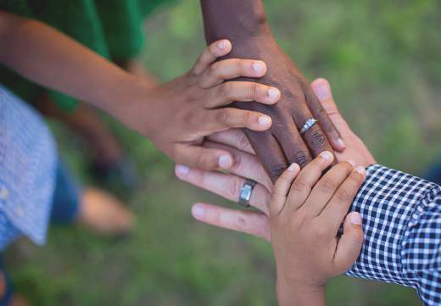

Who Participates?

A Diocesan Leader

A Parish Leader

* **Serves as an ambassador for the CWPI**
* **Promotes participation and engagement among parish leaders**
* **Supports parishes by providing training and educational resources**
* **In coordination with parish leaders, implements the CWPI setting common goals and metrics towards improving physical, spiritual, and pastoral care for those who have serious illness**
* **Oversees the CWPI in the diocese**
* **Is the liaison between the Diocese and the parish**
* **Implements the CWPI in the parish, coordinates, and plans activities such as training for parishioners**
* **Supports parish ministers/volunteers and engages with them**
* **Establishes a supportive community for sick parishioners and their families**
* **Affiliated health care providers**
* **Dioceses in California**
* **Parishes**
* **Community members Families**
* **People facing end-of-life challenges**
* **Ministries who serve the sick and dying such as housebound, bereavement, Legion of Mary, and Eucharistic Ministry**

**The Office of_______________ and the Caring for the Whole Person staff provide resources and training in end-of-life care to better equip parish leaders who have been called to minister to the sick and dying, their families, and the community.**

**Parish leaders plan and organize the training of parish volunteers in the work of CWPI.**

**The training curriculum developed by theologians, ethicists, and health care providers includes topics such as an overview of CWP (body/mind/spirit), palliative care, hospice care, Catholic and moral teachings, caring at end-of- life, advanced care planning, legal decision-making, and grief, as well as tips for pastors, parish leaders, and caregivers.**

HOW DOES

CWPI WORK?